|  |  |  |
| --- | --- | --- |
| Model | Strategy for missing values | Best parameters tuned by 5-fold CV |
| XGBoost | To learn the splitting directions for samples with missing values based on the minimization of training loss [1] | max_depth = 5  eta = 0.3  subsample = 1  colsample_bytree = 0.8 |
| BART | To incorporate missingness by augmenting the nodes’ splitting rules to (a) use missingness itself as a variable to be considered in a splitting rule and (b) also handle sorting the missing data to the left or right [2] | k = 1  num_trees = 150  prob_rule_class = 0.2 |
| Random Forest | To conduct split in a node, the algorithm imputes missing values by drawing randomly from the set of nonmissing in-bag data within the current node [3] | mtry = 2  nodesize = 5  splitrule = “gini”  sampprop = 0.8 |
| Conditional random forest | Splits are determined by only observed variables; then at one node, to pass down observations missing that variable, the algorithm considers surrogate splits. As an example, assume that the split (age < 40, age >= 40) has been chosen. The surrogate variables are found by re-applying the partitioning algorithm (without recursion) to predict the two categories “age <40” vs “age >=40” using the other independent variables. [4] | mtry = 5  maxsurrogate = 0 |

|  |  |  |  |  |  |
| --- | --- | --- | --- | --- | --- |
| Model | AUC | Sensitivity | Specificity | PPV | NPV |
| Training data (threshold) | | | | | |
| XGBoost  (0.312) | 1.000  (0.998,1.000) | 1.000  (0.877,1.000) | 0.989  (0.940,1.000) | 0.966  (0.822,0.999) | 1.000  (0.959,1.000) |
| BART  (0.312) | 0.983  (0.955,0.999) | 0.964  (0.817,0.999) | 0.944  (0.875,0.982) | 0.844  (0.672,0.947) | 0.988  (0.937,1.000) |
| Random Forest  (0.303) | 0.992  (0.979,1.000) | 1.000  (0.877,1.000) | 0.956  (0.890,0.988) | 0.875  (0.710,0.965) | 1.000  (0.958,1.000) |
| Conditional Random Forest  (0.230) | 0.914  (0.856,0.957) | 0.964  (0.817,0.999) | 0.722  (0.618,0.811) | 0.519  (0.376,0.660) | 0.985  (0.918,1.000) |
| Test data | | | | | |
| XGBoost | 0.767  (0.603,0.895) | 0.455  (0.167,0.766) | 0.789  (0.627,0.904) | 0.385  (0.139,0.684) | 0.833  (0.672,0.936) |
| BART | 0.746  (0.567,0.900) | 0.545  (0.234,0.833) | 0.842  (0.687,0.940) | 0.500  (0.211,0.789) | 0.865  (0.712, 0.955) |
| Random Forest | 0.847  (0.711,0.950) | 0.727  (0.390,0.940) | 0.763  (0.598,0.886) | 0.471  (0.230,0.722) | 0.906  (0.750,0.980) |
| Conditional Random Forest | 0.806  (0.639,0.947) | 0.818  (0.482,0.977) | 0.684  (0.513,0.825) | 0.429  (0.218,0.660) | 0.929  (0.765,0.991) |

An optimal threshold is determined based on the ROC curve estimated with the training data, such that the summation of sensitivity and specificity is the largest at the threshold [5]. This is because Youden Index = sensitivity + specificity – 1.

ROC curve based on training data:

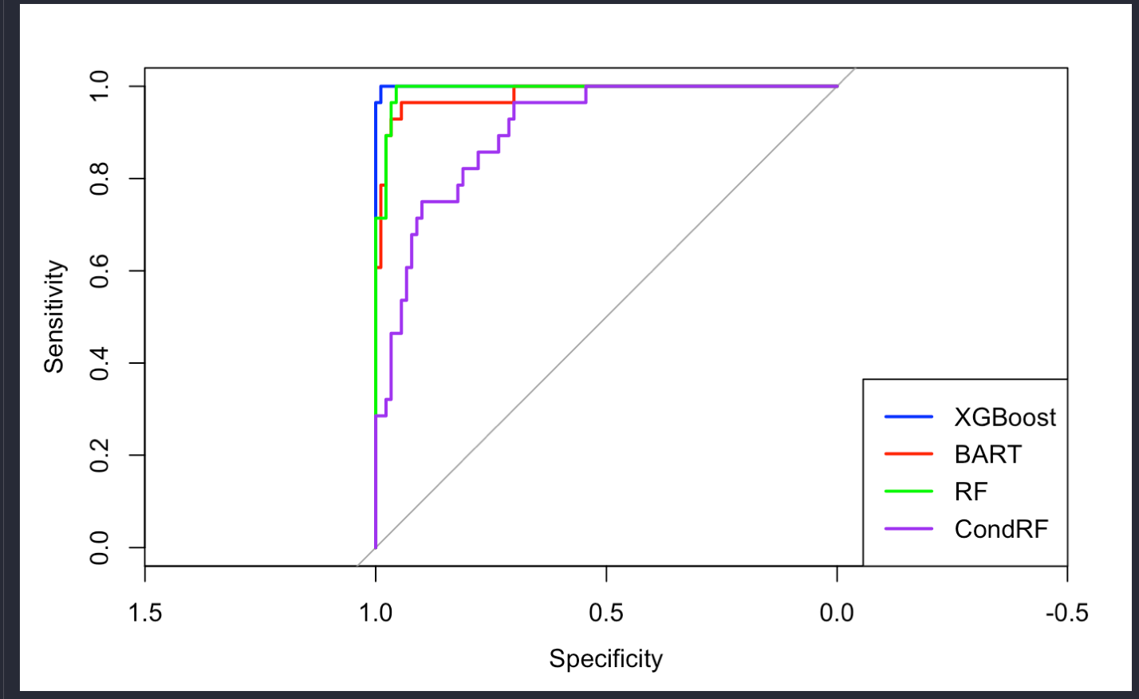

Smoothed ROC curve based on test data:

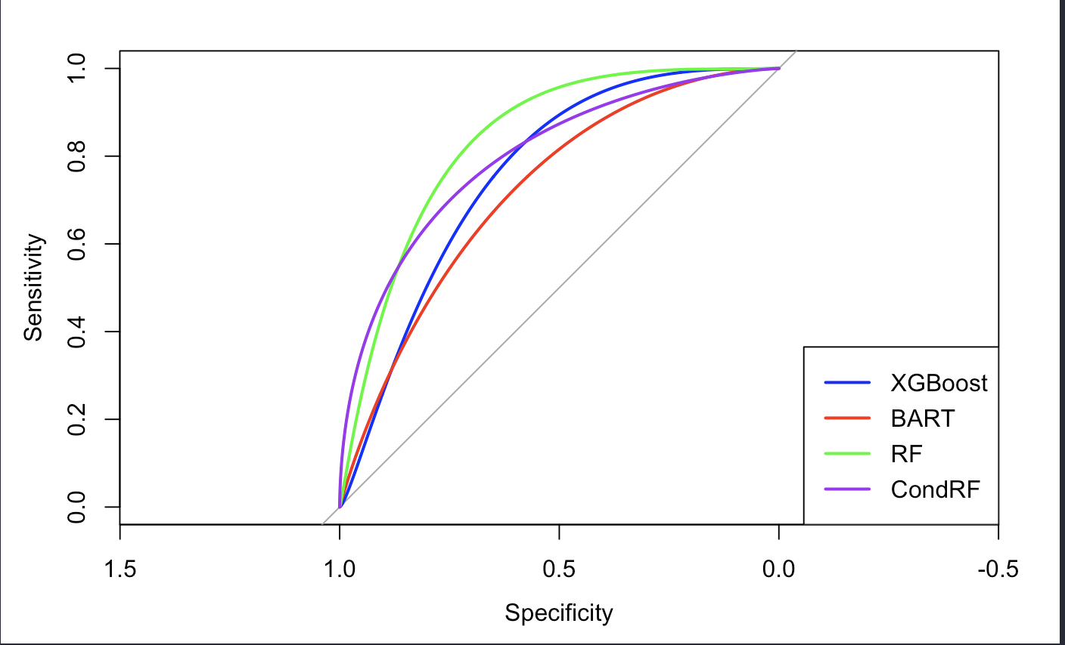

Reference

[1] Chen, T., & Guestrin, C. (2016, August). Xgboost: A scalable tree boosting system. In *Proceedings of the 22nd acm sigkdd international conference on knowledge discovery and data mining* (pp. 785-794).

[2] Kapelner, A., & Bleich, J. (2015). Prediction with missing data via Bayesian additive regression trees. *Canadian Journal of Statistics*, *43*(2), 224-239.

[3] Ishwaran, H., Kogalur, U. B., Blackstone, E. H., & Lauer, M. S. (2008). Random survival forests.

[4] Breiman, L. (2017). *Classification and regression trees*. Routledge.

[5] Schisterman, E. F., Perkins, N. J., Liu, A., & Bondell, H. (2005). Optimal cut-point and its corresponding Youden Index to discriminate individuals using pooled blood samples. *Epidemiology*, *16*(1), 73-81.